Contents
Dealer Monthly PMMB-62 Report 3
Important Notes: 3
After Successful Login 3
Figure 1: Dealer Monthly Navigation 3
Dealer Monthly Dashboard 4
Figure 2: Dealer Monthly Dashboard Displayed 4
Part 1A – Producer Receipts 5
Figure 3: Dealer Monthly Report – Part 1A – Producer Receipts 5
Data Area – How to Enter Data 6
Action Buttons 7
Part 1B – Federal Classification 8
Figure 4: Dealer Monthly Report Part 1B – Federal Classification 8
Data Area 8
Class Pounds 9
Action Buttons 9
Part 2 – Other Receipts 10
Figure 5: Dealer Monthly Report Part 2– Other Receipts 10
Data Area 10
Action Buttons 11
Part 2 Instructions for Dealers located outside of Pennsylvania: 11
Part 3 - All sales of Class I & II Packaged Products to Retailers, Consumers, and Subdealers 12
Figure 6: Dealer Monthly Report Part 3 – All Sales of Class I and II Packaged Products to Retailers, Consumers, and Subdealers 12
Data Area 12
Action Buttons 12
Part 4 – Packaged sales of milk and cream to other dealers 14
Figure 7: Dealer Monthly Report – Part 4 – Packaged Sales of Milk and Cream to Other Dealers 14
Data Area 14
Action Buttons 15
Part 5 – Bulk Sales to Other Dealers 16
Figure 8: Dealer Monthly Report - Part 5 – Bulk Sales to Other Dealers 16
Data Area 16
Action Buttons 16
Part 6 – Class II, III, & IV Manufactured Utilization 18
Figure 9: Dealer Monthly Report - Part 6 – Class II, III, an IV Manufactured Utilization 18
Data Area 18
Instructions for Dealers Located outside of Pennsylvania (Part 6) 18
Data Area 18
Action Buttons 19
Part 7 – Inventories 20
Figure 10: Dealer Monthly Report - Part 7 – Inventories 20
Data Area 20
Action Buttons 20
Part 8 – Subdealer Worksheet 21
Figure 11: Dealer Monthly Report - Part 8 – Subdealer Worksheet 21
Data Area 21
Action Buttons 21
Dealer Submission Page 22
Figure 12: Dealer Submission Page 22
Data Area 22
Action Buttons 22
NO ACTIVITY REPORT 22

Dealer Monthly PMMB-62 Report

Location: MARS > Dealer Monthly

Each PMMB licensed milk dealer must file a monthly report on or before the 25th day of each month. If the 25th day falls on a Saturday, Sunday, or holiday, the report is due the next business day.
- The report covers receipts and utilization of milk for the preceding month.
- If you are operating under a federal market order, you must submit a copy of all reports filed with and received from a federal market administrator for the reporting period.

Once your report has been completed/submitted then an auditor from PMMB staff will review and make any comments/corrections/and/or send back to the dealer for corrections.

Important Notes:
- Please note that these are used for PMMB pricing purposes only and may not coincide with other regulatory agencies.
- Record product pounds and butterfat pounds in whole numbers.
- Carry butterfat test percentages to four decimal places.
- Round to the nearest dollar in fields that request dollar amounts. Do not include cents.
- All Parts will have options to upload supporting documentation.
- You may not see all the report Parts if you do not have to submit all Parts/Schedules of the Dealer Monthly.

After Successful Login

- The first thing you should see when you successfully login into MARS is the screen shown below.
- Click “Dealer Monthly” as shown by the blue arrow.

Figure 1: Dealer Monthly Navigation

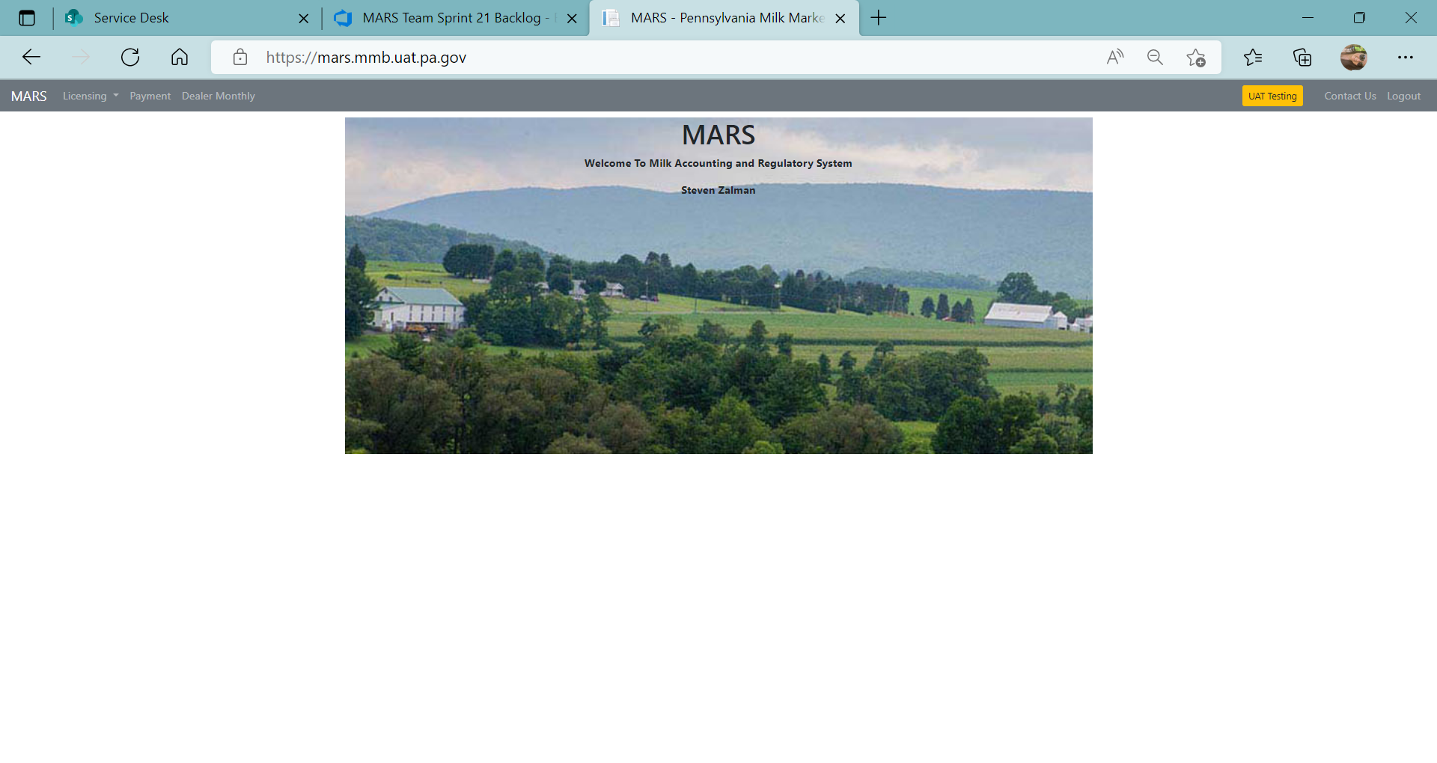

- You will be directed to the Dealer Monthly Dashboard which consists of four sections, explained and shown below in Figure 2.

Dealer Monthly Dashboard

Figure 2: Dealer Monthly Dashboard Displayed
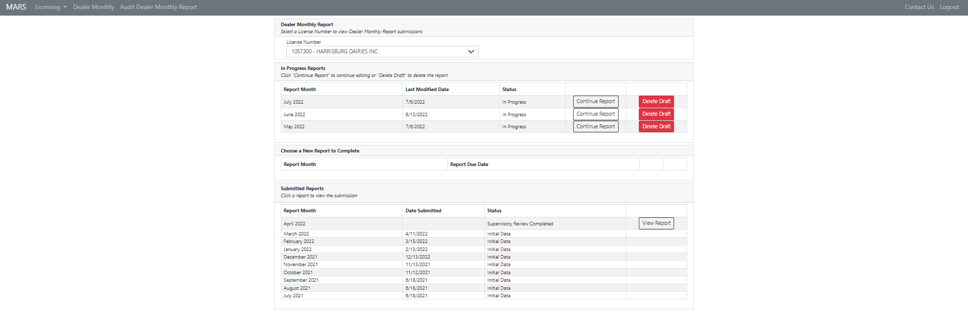
Submitted Reports
Choose a New Report
to Complete
In Progress Report
- Dealer Monthly Report Section
Dealer Monthly Report
This section displays the license number(s) and name(s) of the dairy/dairies associated with your Greenport account. If you are authorized to submit for multiple dealers, those names and license numbers will be shown in the dropdown menu. Select the dealer to view information for that license number.
- If you have only registered one license number for Greenport, you will only see one dealer listed.

- In Progress Reports
This section will display any reports that you have started but have not yet completed and submitted. You can select to delete the draft entirely or continue filling out the report.

- Choose a new Report to Complete
This section will display reports that have not been started. The report month will display on the first of each month and display the due date of the report. Select “Start Report” to begin a report.
- If the report is past due you will also see a notification that is it past due.

- Submitted Reports
This section shows reports that have been submitted for the past year. If a View Report button is visible you will be able to view what was submitted but will be unable to change any data. The View Report button will not be visible while the report is under audit.

- Once you have selected the report on which you want to work, you will be directed to Part 1A – Producer Receipts, Figure 3.

Part 1A – Producer Receipts

Figure 3: Dealer Monthly Report – Part 1A – Producer Receipts
SECTION 1 – Report Information and Navigation
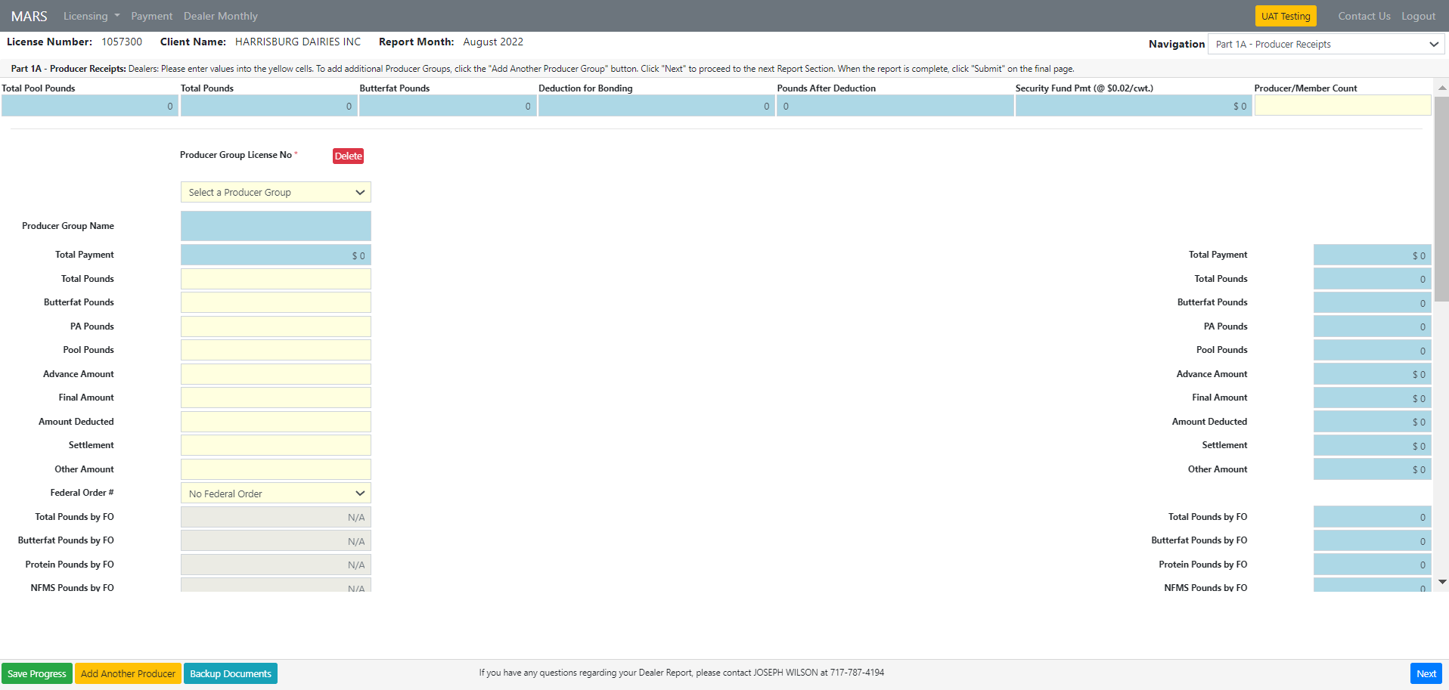
SECTION 3 – Action buttons
SECTION 2 – Data Area

Each of the 8 Parts of the PMMB-62 are broken down into three main sections. See Figure 3.

- Section 1 Report Information and Navigation – The left side of section 1 contains the license number, client name, and report month. The right side of this section is a dropdown titled Navigation. The Navigation dropdown contains all the Parts/Schedules of the 62 and allows you to navigate to each individual Part/Schedule.

- Section 2 Data Area- Data is entered and totaled. Yellow cells are cells where data can be entered. Blue cells are cells that contain totals and other calculations, and you will not be able to change these cells. The data area will typically have a delete button where data columns and rows can be deleted.

- Section 3 Action Buttons– This section contains a button to save your progress, a button to add another column or row to the data section, and a button where you can attach backup documents that pertain to the current Part on which you are working. On the far right is a “Next” button. When “Next” is pressed the current page is saved and the next part is displayed.

Data Area – How to Enter Data

- Producer/Member Count
- For Cooperative Dealers – enter number of PA cooperative members.
- For other Dealers, if you report 7777701 as a producer group, enter the number of independent producers you purchased milk from during the month.
- Use “Producer Group” dropdown to select a producer group. For your “own farm” production use your own license number.
  - For Pennsylvania independent producers select license number 7777701.
  - For non-Pennsylvania independent producers select license number 7777702.

- Enter numeric characters in all fields that are highlighted yellow in Part 1A – Producer Receipts.
- If a field is not applicable input 0.

- Total Pounds - Enter the total product pounds received from the producer group regardless of the state in which the milk originated.

- Butterfat Pounds - Enter the corresponding butterfat pounds received from the producer group.

- PA Pounds - Enter the product pounds of milk that came from Pennsylvania producers.

- Pool Pounds - Enter the product pounds of milk received from the producer group that was pooled under any Federal Milk Marketing Order.

- Advance Amount - enter the total advance payment to the producer group.

- Final Amount - Enter the total final payment to the producer group.

- Amount Deducted - Enter the total of all deductions for hauling or authorized assignments paid on behalf of the producer group.
- Settlement - Enter the amount paid into a producer settlement fund for milk purchased during the reporting period.
- Do not include settlement fund payments or deductions that reflect adjustments for milk purchased in prior periods.
- If federal auditors have adjusted for prior periods, attach the reconciliation, along with all other reports received from a federal market administrator.

- Other Amount - Enter any other amount paid to, or on behalf of, the producer group.

- Federal Order (FO) # - enter the federal order number under which the milk is pooled.
- If it is pooled under more than one federal order, only enter the home federal order number.
- Total Pounds by FO - Enter the total product pounds pooled under each federal order.

- Butterfat Pounds by FO - Enter the associated butterfat pounds pooled under each federal order.

- Protein Pounds by FO- Enter the protein pounds in all milk pooled under each federal order, regardless of class or use.

- NFMS Pounds by FO - Enter the nonfat milk solids pounds in all milk pooled under each federal order, regardless of class or use.

- Other Solid Pounds by FO - For federal orders that calculate the other solids lbs. value, enter the other solids pounds.

- Somatic Cell Amount by FO - Enter the value of the somatic cell adjustment as provided by the Federal Market Administrator, this must agree with the federal report included with your report.

- Advance Amount by FO - Enter the total advance payment to the producer group for milk pooled under the federal order.

- Final Amount by FO - enter the total final payment to the producer group for milk pooled under the federal order.

- Amount Deducted by FO - Enter the total of all deductions for hauling or authorized assignments paid on behalf of the producer group for milk pooled under the federal order.

- Settlement by FO - enter the amount paid into a producer settlement fund for milk purchased during the reporting period for milk pooled under the federal order.
- Include settlement fund payments or deductions that reflect adjustments for milk purchased in prior periods.
- If federal auditors have adjusted for prior periods, attach the reconciliation, along with all other reports received from federal market administrator.

- Other Amount by FO - Enter any other amount paid to, or on behalf of, the producer group.

- Coop Charge Paid - Enter the amount of ‘Coop Charge’ paid to the producer group (co-ops only; PA pounds only) per O.G.O. A-1010.

- OPP Paid - Enter the amount of ‘OOP’ paid to the producer group in accordance with O.G.O. A-893.

- Non-PA Bonded Milk - Enter the product pounds of producer milk purchased in a state (other than PA) where a bond or other security has been filed for the protection of those producers.

- OFO Milk Entry Only - To input information here, click on “Add.”
- This section is to be completed when milk of a producer group is being pooled in a federal order other than the dealer’s ‘home’ federal order or milk that was pooled in home Federal Order by another coop or dealer’.
  - “Enter Class Value” – Enter only the amount paid for milk components (i.e., skim, bf, other solids, somatic cell, …) associated with the OFO milk. Do not account for the value of any premiums paid on OFO milk.
  - Skim Pounds – Enter the skim pounds associated with the OFO milk.
  - Butterfat Pounds – Enter the butterfat pounds associated with the OF milk.

Action Buttons

- Save Progress – Use when saving progress made throughout the dealer monthly report (Green button and located bottom left of page).

- Add Another Producer Group– Used to add another producer, e.g. A dealer has more than one producer under its license number so is required to enter all producers. This button is located at the bottom left of page next to “Save Progress.” It is yellow.

- Backup Documents – Supporting documentation that was normally uploaded with the old PMMB-62 Excel spreadsheet is now added here. You can attach files in each section of the report as needed.

- Next – The “Next” button will navigate you to the next section of the Dealer Monthly Report. It is a blue button located at the bottom right side of the page.

- Delete – This button will allow you to delete a producer group and is located in the data area.

Part 1B – Federal Classification

Figure 4: Dealer Monthly Report Part 1B – Federal Classification
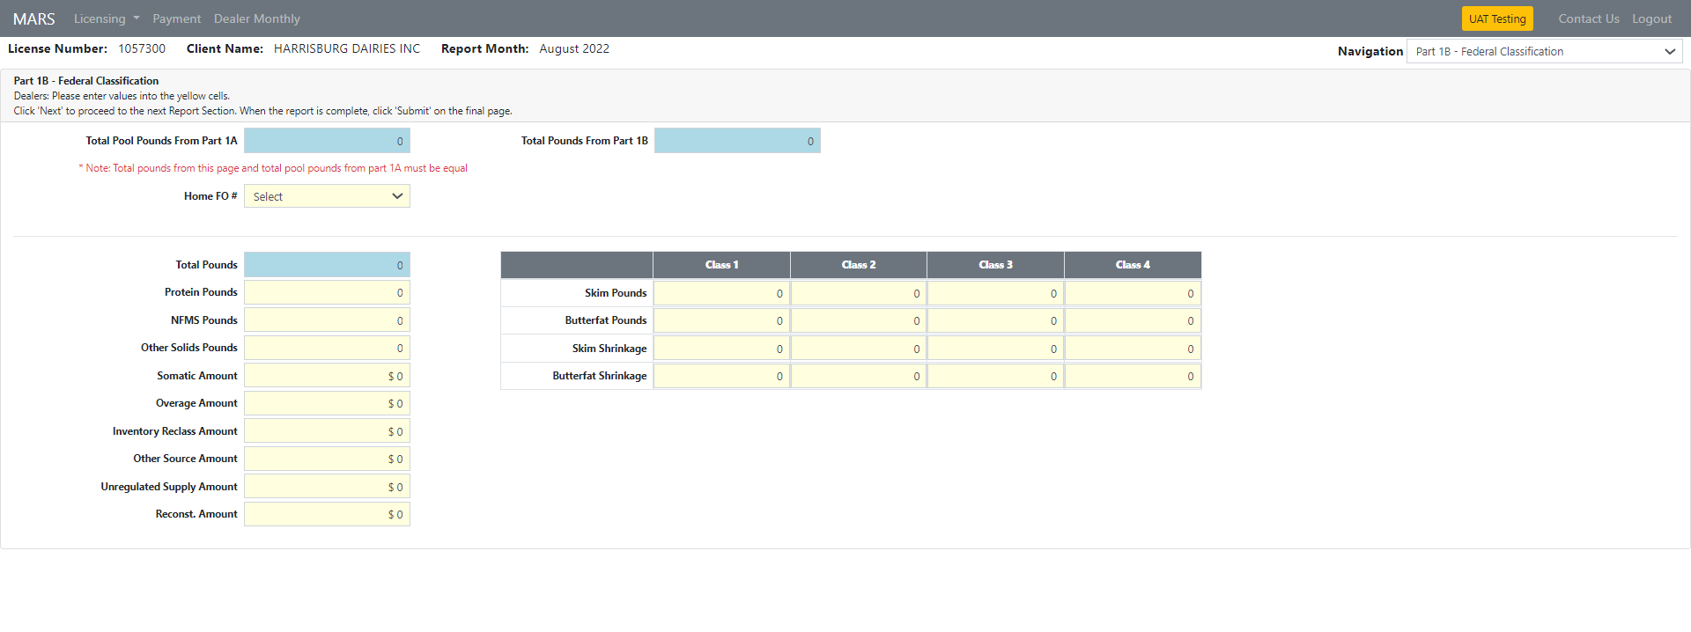

Data Area

- Home FO # - Select the number of your home federal order from the dropdown.

- Protein Pounds - Enter the associated protein pounds.

- NFMS Pounds – Enter associated non-fat milk solid pounds.

- Other Solids Pounds – Enter the associated other solid pounds.

- Somatic Amount – Enter the somatic cell adjustment value provided by the Federal Market Administrator.

- Overage Amount – Enter the value of the overage amount provided by the Federal Market Administrator.

- Inventory Reclass Amount – Enter the value of the inventory reclassification provided by the Federal Market Administrator.

- Other Source Amount – Enter the value of other source milk provided by the Federal Market Administrator.

- Unregulated Supply Amount – Enter the value of the milk designated by the Federal Market Administrator as unregulated.

- Reconst. Amount – Enter the value of reconstituted milk provided by the Federal Market Administrator.

Class Pounds

- Skim Pounds – Enter skim pounds assigned to each class for milk pooled in the home federal order.

- Butterfat Pounds – Enter butterfat pounds assigned to each class for milk pooled in the home federal order.

- Skim Shrink – Enter the pounds of skim shrinkage assigned to each class for milk pooled in the home federal order.

- Butterfat Shrink – Enter the pounds of butterfat shrinkage assigned to each class for milk pooled in the home federal order.

Action Buttons

- Save Progress – Use the “Save Progress” button when saving progress made throughout the dealer monthly report. It is a green button located at the bottom left of the page.

- Backup Documents – Supporting documentation that was normally uploaded with old PMMB-62 Excel spreadsheet is now attached here.

- Next – The “Next” button will navigate you to the next section of the dealer monthly report. It is a blue button located at the bottom right side of the page.

Part 2 – Other Receipts

Use this section to record purchases of bulk milk, bulk cream, bulk skim, ice cream mix, water, packaged milk, and packaged cream from other dealers, producer-dealers, and juggers. For packaged purchases, combine similar products received from a single dealer that fall within a particular product description and butterfat range.

Figure 5: Dealer Monthly Report Part 2– Other Receipts

- For juggers located in Pennsylvania, use license number 8888800; for juggers outside Pennsylvania, use license number 8888801.
- For all dealers located in Pennsylvania which are licensed by the Board:
- Current license numbers are located on the Board website - www.mmb.pa.gov
- If the licensee is not listed, please call the Milk Marketing Board at (717) -787-4194 and request to speak with an audit supervisor.
  - Licensees may have a “Doing Business As” name different than the name they are licensed under.
- For dealers located outside the state not licensed by the Board, use license numbers 9999200 through 9999298.

- Stores licensed as Dealers under a tolling agreement (or service contract) under OGO A-975 are to report receipts under the tolling agreement on Part 2; these receipts should equal the corresponding sales reported on Part 3.

Important Note: Report all ingredients, including water, powder, and any condensed or concentrated product that are used in reconstituting a price-controlled packaged product

Data Area

- License number – Select selling dealer’s license number by using the dropdown. If the dealer does not exist in the list, select 99992xx.
- When 99992xx is selected the dealer’s name field will be mandatory.

- Product Code - Select the appropriate product code by using the dropdown.

- Butterfat Percent - Enter the butterfat percent to four decimal places.

- BF % Range – Will show the suggested range that is accepted.

- Cost – Enter the total cost for each bulk purchase.
- If this information is not required for the type of product it will be grayed out.

- Diverted/Transferred - For bulk purchases:
- Select “Diverted” if the milk was diverted (not received at the selling plant and diverted to your location).
- Select “Transferred” if the milk or cream was transferred (received at the selling plant and transferred to your location).
- If this information is not required for the type of product it will be grayed out.

Action Buttons

- Save Progress – Use when saving progress made throughout the dealer monthly report. The “Save Progress” button is green and is located at the bottom left of the page.

- Add Another – This button is used to add another row for other receipts, click ‘Add Another’ is a yellow button located at the left of the page.

- Backup Documents – Supporting documentation that was normally uploaded with the old PMMB-62 Excel spreadsheet is now attached here.

- Next – The “Next” button navigates you to the next section of the dealer monthly report. It is a blue button located at the bottom right side of the page.

- Delete Button – The “Delete” button is used to delete anything that was unnecessary, or incorrectly added (is a red button located on the right side after each row. See Figure 5.

Part 2 Instructions for Dealers located outside of Pennsylvania. A Part 2 balancing entry is necessary if the difference of pounds for total sales into Pennsylvania (Parts 3, 4 and 5) minus total purchases from Pennsylvania producers and dealers (Parts 1 & 2) is greater than 0.

- License Number - Enter your license number as 99992xx, where xx is the next available number in the 99992 sequence.

- Name of Selling Dealer - Enter the words “Balancing Entry.”

- Product Code - Enter product code 3901.

- Product Pounds - Enter the difference of product pounds for total sales into Pennsylvania (Parts 3, 4 and 5) minus total purchases from Pennsylvania producers and dealers (Parts 1 & 2).

- Butterfat Pounds - Enter the difference of butterfat pounds for total sales into Pennsylvania (Parts 3, 4 and 5) minus total purchases from Pennsylvania producers and dealers (Parts 1 & 2).

- Butterfat Percent - Enter the butterfat percent to four decimal places.

Part 3 - All sales of Class I & II Packaged Products to Retailers, Consumers, and Subdealers

Use this section to record the sales of Class I and Class II packaged products. Include all sales of packaged milk and cream to retailers, consumers, and subdealers. Combine similar products that fall within a particular product description and butterfat range.

Figure 6: Dealer Monthly Report Part 3 – All Sales of Class I and II Packaged Products to Retailers, Consumers, and Subdealers

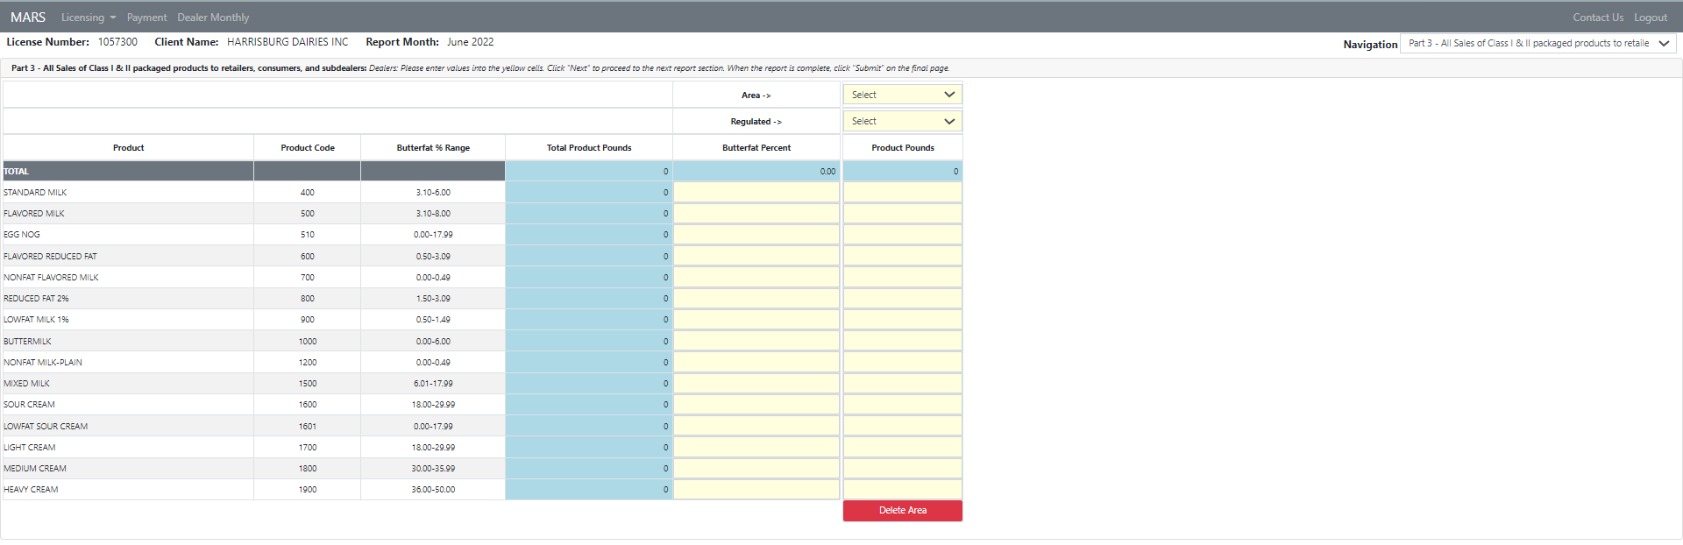

Stores licensed as Dealers under a tolling agreement (or service contract) under OGO A-975 are to report the tolling agreement (or service contract) sales on Part 3.
- These sales should equal the corresponding receipts reported on Part 2. See Figure 5.

Data Area

- Butterfat Percent - Enter the butterfat percent for each product code to four decimal places. Butterfat tests should correspond to ranges that are listed in ‘Butterfat % Range.’

- Area – Select area range dropdown menu (ranges from 1-0 through 9-9).

- Regulated – Choose “Yes” or “No” from the dropdown menu. Unregulated sales are those which are not subject to PMMB minimum Resale pricing (i.e., sales into non-PA areas, sales at own-farm store AND sales into PA areas to institutions located on federally granted land).

- Product Pounds - Enter product pounds for all fields highlighted yellow that are greater than 0.

Action Buttons

- Save Progress – Ese when saving progress made throughout the dealer monthly report. The “Save Progress” button is green and is located at the bottom left of the page.

- Add Another Area– To add another row for another area, click the ‘Add Another Area” button, a yellow button located at the bottom left of the page.

- Backup Documents – Supporting documentation that was normally uploaded with the old PMMB-62 Excel spreadsheet is now attached here.

- Next – The “Next” button will navigate you to the next section of the dealer monthly report. It is a blue button and is located at the bottom right side of the page.

- Delete Area – The “Delete Area” button will allow you to delete anything that was unnecessary or incorrectly added. It is a red button located at the bottom of each column.

Part 4 – Packaged sales of milk and cream to other dealers

Use this section to record the Class I and Class II packaged sales to other dealers.

Figure 7: Dealer Monthly Report – Part 4 – Packaged Sales of Milk and Cream to Other Dealers

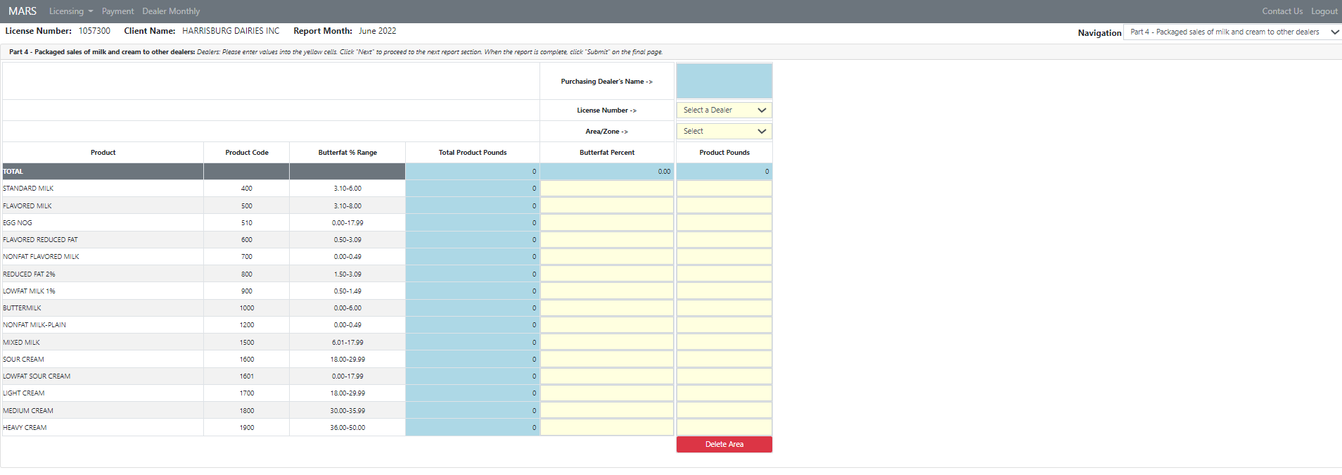

Combine similar products that fall within a particular product description and butterfat range.
- Class I and Class II sales of price-controlled packaged products to subdealers and to businesses not licensed by the Pennsylvania Milk Marketing Board located within Pennsylvania should be listed in PART 3 - ROUTE DISPOSITION.).
- Only licensed stores that are a party to a tolling agreement (or service contract) under OGO A-975, and the sales made to those stores under the tolling agreement (or service contract), are to be reported on Part 4. All other sales made to those stores are to be reported on PART 3 – ROUTE DISPOSITION.
- Non-PA dealers only need to report their sales into PA. A non-PA dealer is not required to report sales to other non-PA dealers.
- No other product codes are valid for this section.
- If you have questions regarding how to combine products, contact the Harrisburg office of the Milk Marketing Board at (717)-787-4194.

Data Area

- Butterfat Percent – Enter the butterfat percent to four decimal places. Butterfat percent should correspond to the range listed in ‘Butterfat % Range.’

- License Number – Select license number from license listing dropdown.
- For dealers located outside Pennsylvania not licensed by the Milk Marketing Board, use license numbers 9999400 through 9999499.
- If you are unable to find a license number for a Pennsylvania-located dealer from the license listing on the Milk Marketing Board’s website, please call the Milk Marketing Board at (717)-787-4194 and request to speak with an audit supervisor.

- Area/Zone – Select the PA Milk Marketing Area/zone from the dropdown menu provided.

- Product Pounds – Enter packaged sales to individual dealers by product pounds and by each individual area.

Action Buttons

- Save Progress – Use the “Save Progress” button when saving progress made throughout the dealer monthly report. It is a green button located at the bottom left of the page.

- Add Another Dealer– To add another row for another dealer, click the ‘Add Another Dealer button, a yellow button located at the bottom left of the page.

- Backup Documents – Supporting documentation that was normally uploaded with the old PMMB-62 Excel spreadsheet is now attached here.

- Next – The “Next” button will navigate you to the next section of the dealer monthly report. This is a blue button located at the bottom right side of the page.

- Delete Area – The “Delete Area” button will allow you to delete anything that was unnecessary or incorrectly added. It is a red button located at the bottom of each column.

Part 5 – Bulk Sales to Other Dealers

Use this section to record only the sale of bulk milk or cream to other dealers.

Figure 8: Dealer Monthly Report - Part 5 – Bulk Sales to Other Dealers

Important Note: Two separate entries are needed for bulk sales (diversions only) from both Pennsylvania and non-Pennsylvania producers, one for the Pennsylvania producers and one for the non-Pennsylvania producers.

Data Area

- License Number – Select license number from license dropdown menu.
- For Dealers located outside Pennsylvania not licensed by the Board use license numbers 999950 through 9999598.
- If you are unable to find a license number for a Pennsylvania located dealer from the license listing on the Milk Marketing Board’s website, please call the Milk Marketing Board at (717)-787-4194 and request to speak with an audit supervisor.

- Product Code – Select appropriate product code from dropdown menu.

- Product Pounds – Enter the amount of total product pounds.

- Butterfat Percent – Enter the butterfat percent to four decimal places.

- Revenue – Enter the total amount of revenue received, excluding hauling charges if paid by purchaser.
- If this cell is grayed out it is not required.

- Diverted/Transferred –
- Select “diverted” if the milk was diverted, meaning not initially received at the selling dealer’s plant.
- Select “Transferred” if the milk or cream was transferred, meaning initially received at the selling dealer’s plant.

- Check ‘If Pool Milk’ – Check if the milk in this sale is part of a federal order pool calculation.

- Check ‘If Milk from Non-PA Producers’ – Check if the milk in this sale is not from PA producers.

- Where Sold – Select the PA Milk Marketing Area where milk was sold to from the dropdown menu.

- Producer Group Name – Select the producer group name from the list available (based on license number provided).
- If this cell is grayed out it is not required.

- Loc. Adj. (Producer Location Adjustment) – The Producer Location Adjustment for each diversion of bulk Pool milk is automatically calculated by subtracting the Class 1 plant differential of the Purchasing plant from the base Class 1 differential ($2.00 if pooled under F.O. 33 or $3.25 if pooled under F.O. 1). The calculated location adjustment may be over-written if necessary.

Action Buttons

- Save Progress – Use this button when saving progress made throughout the dealer monthly report. The “Save Progress” button is a green button located at the bottom left of the page.

- Add Another Purchaser– If you wish to add another row for another purchaser, click the “Add Another Purchaser” button, which is a yellow button located at the bottom left of the page.

- Backup Documents – Supporting documentation that was normally uploaded with the old PMMB-62 Excel spreadsheet is now attached here.

- Next – This button will navigate you to the next section of the dealer monthly report. The “Next” button is a blue button located at the bottom right side of the page.

- Delete – The “Delete” button allows you to delete anything that was unnecessary, or incorrectly added. It is a red button located on the right side after each row.

Part 6 – Class II, III, & IV Manufactured Utilization

Use this section to record any milk and/or cream utilized in the manufacturing of products which are not subject to PMMB minimum resale pricing.

Figure 9: Dealer Monthly Report - Part 6 – Class II, III, an IV Manufactured Utilization

Data Area

- Product Code – Enter appropriate product code from the dropdown menu.

- Product Pounds – Enter the total product pounds of milk, skim and cream used to make the manufactured product.
- Do not enter yield pounds.

- Butterfat Percent – Enter the butterfat percent to four decimal places.

- Butterfat % Range – No entry is necessary; this is guidance suggesting butterfat ranges that are acceptable

Instructions for Dealers Located outside of Pennsylvania (Part 6)
Unless otherwise instructed, a dealer located outside Pennsylvania should enter the following:

Data Area

- Product Code – Select Product Code 9901 from the dropdown menu.

- Description of Products Manufactured – ‘Other’ will display as the description once ‘Product Code 9901’ has been selected from the dropdown menu.

- Product Pounds - Enter the sum of all Pennsylvania purchases (Parts 1 and 2) less the sum of all sales back into Pennsylvania (Parts 3, 4 and 5), if greater than zero.
- If less than zero, skip PART 6 entirely.

Important Note: IF
- Only product pound sales into Pennsylvania are greater than purchases from Pennsylvania producers and dealers
and
- Butterfat pound sales into Pennsylvania are less than or equal to purchases from Pennsylvania producers and dealers,
then Enter the butterfat pound sales less the butterfat pound purchases from Pennsylvania producers and dealers.

- Butterfat % - Enter the butterfat percent to four decimal places. That is the butterfat percent that would correspond to the butterfat pounds associated.

Action Buttons

- Save Progress – Use when saving progress made throughout the dealer monthly report. The “Save Progress” button is green and is located at the bottom left of the page.

- Add Another Product– To add another row for another purchaser, click the “Add Another Product” button, a yellow button located at the bottom left of the page.

- Backup Documents – Supporting documentation that was normally uploaded with the old PMMB-62 Excel spreadsheet is now added here throughout the dealer monthly report. You are now able to attach files in each section of the report. This button is aqua and located at the left-hand side of the page.

- Next – This button will navigate you to the next section of the dealer monthly report. The “Next” button is blue and is located at the bottom right side of the page.

- Delete – The “Delete” button allows you to delete anything that was unnecessary, or incorrectly added. It is a red button located on the right side after each row.

Part 7 – Inventories

Figure 10: Dealer Monthly Report - Part 7 – Inventories

Data Area

- Enter the beginning and end of the month inventory by class according to the official general order affecting your area.

- Enter Product Pounds in ‘Product Pounds’ columns.

- Enter Butterfat Pounds in ‘Butterfat Pounds’ columns.

The variances will be calculated automatically on the right-hand side titled ‘Variance (End minus Beginning).

Important Note: The current month’s beginning inventory should be the same as the previous month’s ending inventory.

Action Buttons

- Save Progress – Use the “Save Progress” button when you want to save progress made throughout the dealer monthly report. It is a green button located at the bottom left of the page.

- Backup Documents – Supporting documentation that was normally uploaded with the old PMMB-62 Excel spreadsheet is now added here throughout the dealer monthly report. You are now able to attach files in each section of the report. The “Backup Documents” button is aqua and located at the left-hand side of the page.

- Next – This button will navigate you to the next section of the dealer monthly report. The “Next” button is a blue button located at the bottom right side of the page.

Part 8 – Subdealer Worksheet

Use this section to record sales activity to subdealers.

Figure 11: Dealer Monthly Report - Part 8 – Subdealer Worksheet

Data Area

- Subdealer’s Number – Select the Subdealer’s number from the dropdown menu.
- Subdealers’ list may be found on the Milk Marketing Board’s website at www.mmb.pa.gov

- Milk Value – Enter total dollar value of price-controlled packaged products for all milk/cream sold to this Subdealer during the reporting period.
- This amount should be net of any discounts or rebates.

- Total Quarts – Enter total quarts/points of fluid milk/cream products corresponding to Milk Value.

- Days Balance Outstanding – Enter current number of days outstanding for the Subdealer as recorded in the accounts receivable register.

Important Note: Make sure all columns are correctly filled in for each entry.

Action Buttons

- Save Progress – Use the “Save Progress” button when saving progress made throughout the dealer monthly report. It is a green button located at the bottom left of the page.

- Backup Documents – Supporting documentation that was normally uploaded with the old PMMB-62 Excel spreadsheet is now added here throughout the dealer monthly report. You are now able to attach files in each section of the report. The “Backup Documents” button is aqua and is located at the bottom left of the page.

- Add Another Subdealer– To add another row for another subdealer, click the “Add Another subdealer” button, a yellow button located at the bottom left of the page.

- Next – The “Next” button will navigate you to the next section of the dealer monthly report. It is a blue button located at the bottom right side of the page.

Dealer Submission Page

Figure 12: Dealer Submission Page

Data Area

- Upload any general backup documentation that wasn’t uploaded previously in each Part.

- After you have uploaded any attachments, you will fill out the information as follows:
- Name,
- Date (this will pre-populate the date you are submitting the Dealer Monthly Report),
- Telephone number,
- e-Mail address, and
- Comments box if necessary.

Action Buttons

- Click “Submit” and a copy of your submission will be emailed to you.

NO ACTIVITY REPORT

- Check NO Activity Report if filing a no activity report.

